**Chapter 2**

**GENERAL COMPONENTS**

**2.1 RESISTORS**

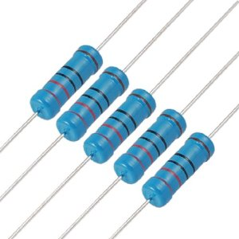

Fig 2.1 Resistors

In many electronic circuit applications the resistance forms the basic part of the circuit. The reason for inserting the resistance is to reduce current or to produce the desired voltage drop. These components which offer value of resistance are known as resistors. Resistors may have fixed value i.e., whose value cannot be changed and are known as fixed resistors. Such of those resistors whose value can be changed or varied are known as variable resistors.

There are two types of resistors available. They are:

1. Carbon resistors.
2. Wire wound resistors.

Carbon resistors are used when the power dissipation is less than 2W because they are smaller and cost less. Wire wound resistors are used where the power dissipation is more than 5W. In electronic equipments carbon resistors are widely used because of their smaller size.

All resistors have three main characteristics:

1. Its resistance R in ohms (from 1 ohm to many mega ohms).
2. Power rating (from several 0.1W to 10 W).
3. Tolerance (in percentage).

**2.1.1 RESISTOR COLOR CODING**

The carbon resistors are small in size and are color coded to indicate their resistance value in ohms. Different colors are used to indicate the numeric values. The dark colors represent lower values and the lighter colors represent the higher values. The color code has been standardized by the electronic industries association.

The color bands are printed at one end of the resistors and are read from the left to right. The first color band closed to the edge indicates the first digit in the value of resistance .The second band gives the second digit. The third band gives the number of zero’s after two digits. The resulting number is the resistance in ohms. A fourth band indicates the tolerance i.e., to indicate how accurate the resistance value is, the bands are shown in the figure 2.2 .

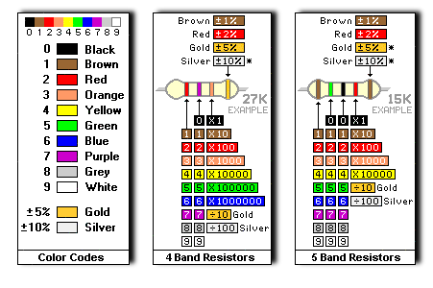

Fig 2.2 Colour code for Resistor

**2.2 POTENTIOMETER**

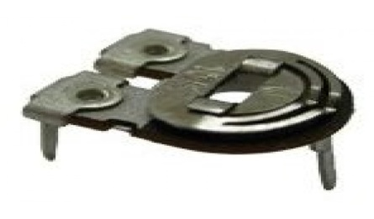

Fig 2.3 Potentiometer

There are two general categories of variable resistors:

1. General purpose resistors.
2. Precision resistors.

The general purpose type can again be wire wound type and carbon type .These follows either linear or logarithmic law. The precision type are always wire wound and follow a linear law .The variable resistors can be broadly classified as potentiometer , rheostats , presets and decade resistance boxes.

The general purpose wire wound potentiometers are available in 1, 2, 3 and 4 watts. The usual tolerances ratings 10 % and 20% are available. The widely used potentiometers are of the standard diameters 19mm, 31mm, and 44mm. The temperature coefficient depends on the wire used and on the resistors values. The resolution of these wire wound resistors is proper than carbon resistors because the wiper has to move from one winding to the other, where as in carbon potentiometers it is continuous. These resistors are highly linear, the linearity falling with 1%.

**2.3 CAPACITORS**

Devices which can store electronic charge are called capacitors. Capacitance can be understood as the ability of a dielectric to store electric charges. Its unit is Farad, named after the Michael Faraday. The capacitors are named according to the dielectric used. Most common ones are air, paper, and mica, ceramic and electrolytic capacitors.

Physically a capacitor has conducting plates separated by an insulator or the dielectric. The plates of the capacitor have opposite charge, this gives rise to an electric field .In capacitor the electric field is concentrated in the dielectric between the plates.

Like resistors, capacitors are also crucial to the correct working of nearly every electronic circuit and provide us with a means of storing electrical energy in the form of an electric field. Capacitors have numerous applications including storage capacitors in power supplies, coupling of A.C. signals between the stages of an amplifier, and decoupling power supply rails so that, As far as A.C. signal components are concerned, the supply rails are indistinguishable from zero volts.

**2.3.1 TYPES OF CAPACITORS**

* **Disc Capacitors**

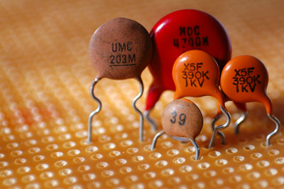

Fig 2.4 Disc Capacitor

In the disk form, silver is fired on to both sides of the ceramic to form the conductor plates. The sheets are then baked and cut to the appropriate shape and size & attached by pressure contact and soldering. These have high capacitance per unit volume and are very economical. The disks are lacquered or encapsulated in plastic or Phenolic molding. Round disk are used at high voltages the capacitance of values upto 0.01F can be obtained. They have tolerance of +20% or –20%. In general these capacitors have voltage ratings up to 750 V D.C.

* **Electrolytic Capacitors**

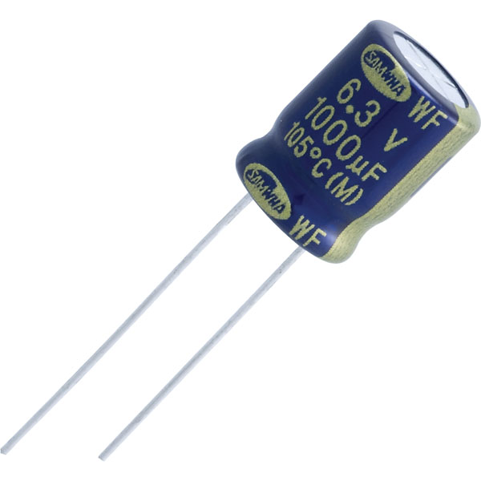

Fig 2.5 Electrolytic Capacitor

These capacitors derive the name from electrolyte which is used as a medium to produce high dielectric constants. These capacitors have low value for large capacitances at low working voltages.

There are two types of Electrolytic capacitors:

1. Aluminum Electrolytic capacitors.
2. Tantalum electrolytic capacitors.

Electrolytic capacitors are used in circuits that have combination of D.C. voltage and A.C. The D.C. voltage maintains the polarity. They are used as ‘ripple filter’ where large capacitance are required at low cost in small space. They are also used as ‘biased capacitors’, ‘decoupling capacitors’ and even as ‘coupling capacitors’ in R- C amplifier.

**2.3.2 COLOR CODING**

Mica and tubular ceramic capacitors are color coded to indicate a capacitance value. As coding is necessary only for very small sizes, color coded capacitors value is also in the pF. The color coding is as same as the resistor coding from black ‘0’ upto white ‘9’. Mica capacitors use ‘six dot code system’.

**2.3.3 SIX DOT CODE**

Here the top row is read from the left to right and the bottom from right to left .The dot indicates the following:

1. White (2) Digit. (3). Digit. (4). Multiplier. (5). Tolerance. (6). Class.

White for the first dot indicates the coding. The capacitance value is read from the next three dots. If the first dot is silver it indicates paper capacitor. The white coloured band indicates the left and specifies the temperature coefficient. The next three colours indicate the value of capacitance. For example Brown, Black, Brown = 100 pF.

**2.4 DIODES**

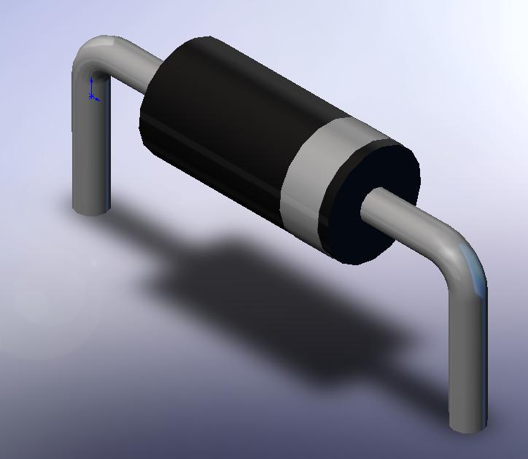

Fig 2.6 Diode

To ensure unidirectional flow of liquid we use mechanical valves in its path. By properly arranging these valves in a system we get useful devices such as pumps and locomotives. In the field of electronics too we have a valve called semiconductor diode (a counterpart of thermionic valve) for controlling the flow of electric current in one direction. But we use these diodes in circuits for limited purposes like converting AC to DC, by passing EMF etc. a diode allows current to pass through it provided it is forward biased and the biasing voltage is more than potential barrier (forward voltage drop) of the diode.

A diode is a two-[terminal](https://en.wikipedia.org/wiki/Terminal_(electronics)) [electronic component](https://en.wikipedia.org/wiki/Electronic_component) that conducts [current](https://en.wikipedia.org/wiki/Electric_current) primarily in one direction (asymmetric [conductance](https://en.wikipedia.org/wiki/Electrical_conductance)); it has low (ideally zero) [resistance](https://en.wikipedia.org/wiki/Electrical_resistance_and_conductance) in one direction, and high (ideally infinite) [resistance](https://en.wikipedia.org/wiki/Electrical_resistance_and_conductance) in the other. A semiconductor diode, the most common type today, is a [crystalline](https://en.wikipedia.org/wiki/Crystallinity) piece of [semiconductor](https://en.wikipedia.org/wiki/Semiconductor) material with a [p–n junction](https://en.wikipedia.org/wiki/P%E2%80%93n_junction) connected to two electrical terminals. A [vacuum tube](https://en.wikipedia.org/wiki/Vacuum_tube) diode has two [electrodes](https://en.wikipedia.org/wiki/Electrode), a [plate](https://en.wikipedia.org/wiki/Plate_electrode) (anode) and a [heated cathode](https://en.wikipedia.org/wiki/Hot_cathode). Semiconductor diodes were the first [semiconductor electronic devices](https://en.wikipedia.org/wiki/Semiconductor_device). The discovery of [crystals](https://en.wikipedia.org/wiki/Crystal)' [rectifying](https://en.wikipedia.org/wiki/Rectification_(electricity)) abilities was made by German physicist [Ferdinand Braun](https://en.wikipedia.org/wiki/Ferdinand_Braun) in 1874. The first semiconductor diodes, called [cat's whisker diodes](https://en.wikipedia.org/wiki/Cat%27s_whisker_diode), developed around 1906, were made of mineral crystals such as [galena](https://en.wikipedia.org/wiki/Galena). Today, most diodes are made of [silicon](https://en.wikipedia.org/wiki/Silicon), but other materials such as [selenium](https://en.wikipedia.org/wiki/Selenium) and [germanium](https://en.wikipedia.org/wiki/Germanium) are sometimes used.

**2.5 TRANSISTOR**

The transistor an entirely new type of electronic device is capable of achieving amplification of weak signals in a fashion comparable and often superior to that realized by vacuum tubes. Transistors are far smaller than vacuum tube, have no filaments and hence need no heating power and may be operates in any position. They are mechanically strong, hence practically unlimited life and can do some jobs better than vacuum tubes.

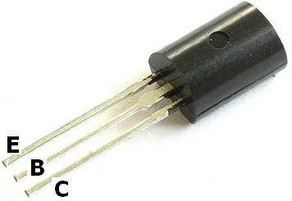

Fig 2.7 Transistor

Invented in 1948 by J. Bardeen and W.H. Brattain of Bell Telephone Laboratories, a transistor has now become the heart of most electronic appliance. Though transistor is only slightly more the 45 years old, yet it is fast replacing vacuum tubes in almost all applications.

A transistor consists of two pn junction formed by sand witching either p-type or n-type semiconductor between a pair of opposite type. Accordingly, there are two types of transistors namely:

1. n-p-n transistor
2. p-n-p transistor

An n-p-n is composed of two n-type semiconductors separated a by thin section of p-type. However, a p-n-p is formed by two p-section separated by a thin section of n-type.

1. These are two pn junctions. Therefore, a transistor may be regarded as a combination two diodes connected back to back.
2. There are 3 terminals, taken from each type of semiconductor.
3. The middle section is very thin layer. This is the most important factor in the functioning of a transistor.

When new devices are invented, scientists often try to device a name that will appropriately describe the device. A transistor has two pn junctions. As the discussed later one junction is forward biased and the other is reversed biased. The forward biased junction has low resistance path whereas the reverse biased junction has low resistance path whereas the reverse biased junction has a high resistance path. The weak signal is introduced in the low resistance circuit and output is taken from the high resistance circuit. Therefore, a transistor transfers a signal from a low resistance to high resistance. The prefix ‘tans’ means the signal transfer property of the device while ‘istor’ classifies it as a solid element in the same general family with resistors.

**2.5.1 TRANSISTOR TERMINALS**

A transistor (pnp or npn) has three sections of doped semiconductors. The section on one side is the emitter and the section on the opposite side is the collector. The middle section is called the base and forms two junctions between the emitter and collector.

1. Emitter - The section on one side that supplies charge carriers (electrons or holes) is called the emitter. The emitter is always forward biased w.r.t base so that it can supply a large number of majority carriers.
2. Collector - The section on the other side that collects the charge is called the collector. The collector is always reversing biased. Its function is to remove charges from its junction with the base.
3. Base - The middle section, which forms to pn junctions between the emitter and collector, is called base. The base emitter junction is forward biased, allowing low resistance for the emitter circuit. The base-collector junction is reversed biased and provides high resistance in the collector circuit.

# 2.5.2 CHRACTERISTICS OF TRANSISTOR

Whenever we have to decide about the applications of a transistor certain question arises. Some of these are – how much amplification gets from it? What is the highest frequency upto which it can be used? How much power output could we get from it? And what should be the values of different components used in the circuits? The answers to these entire questions lie in the electrical properties of the transistor. These properties depend on the size, manufacturing techniques and materials used in the manufacturer of transistor and are known as characteristics. Transistor manufacturers give these characteristics in the data sheets published by them.

* + 1. Current gain factor ‘alpha’ (α)
    2. Current gain factor ‘beta’ (β)
    3. Input resistance (Rin)
    4. Output resistance (Rout)
    5. Cut-off frequency (F α and Fβ)
    6. Leakage current (Ico)
    7. Maximum permissible limits:
       - 1. Maximum collector voltage (Vceo)
         2. Maximum emitter current (IC Max)
         3. Maximum Power dissipation (P max)

**2.6 INTEGRATED CIRCUITS**

All modern digital systems rely on the use of integrated circuits in which hundreds of thousands of components are fabricated on a single chip of silicon. A relative measure of the number of individual semiconductor devices within the chip is given by referring to its ‘scale of integration’. The following terminology is commonly applied.

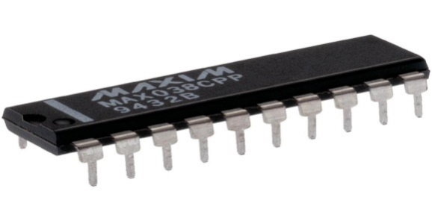

Fig 2.8 Integrated circuits

Scale of integration Abbreviation Number of logic gates

Small SSI 1 to 10

Medium MSI 10 to 100

Large LSI 100 to 1000

Very large VLSI 1000 to 10,000

Super large SLSI 10,000 to 100,000

Table 2.1 Scale of Integration

# 2.6.1 ENCAPSULATION

The most common package used to encapsulate an integrated circuit, and that with which most reader will be familiar, is the plastic dual-in-line (DIL) type.

These are available with a differing number of pins depending upon the complexity of the integrated circuit in question and, in particular, the need to provide external connections to the device. Conventional logic gates, for example, are often supplied in 14-pin or 16-pin DIL packages, whilst microprocessors (and their more complex support devices) often require 40-pins or more.

# 2.6.2 IDENTIFICATION

When delving into an unfamiliar piece of equipment, one of the most common problems is that of identifying the integrated circuit devices. To aid us in this task, manufacturers provide some coding on the upper surface of each chip. Such a coding generally includes the type number of the chip (including some of the generic coding), the manufacturer’s name (usually in the form of prefix letters), and the classification of the device (in the form of a prefix, infix or suffix).

In many cases the coding is further extended to indicate such things as encapsulation, date of manufacture, and any special characteristics of the device. Unfortunately, all of this potentially useful information often leads to some considerable confusion due to inconsistencies in marking from one manufacturer to the next.

# 2.6.3 LOGIC FAMILIES

The integrated circuit device on which modern digital circuitry depends belongs to one or other of several ‘logic families’. The term simply describes the type of semiconductor technology employed in the fabrication of the integrated circuit. This technology is instrumental in determining the characteristics of a particular device. This, however, is quite different from its characteristics, and encompasses such important criteria as supply voltage, power dissipation, switching speed and immunity to noise.

The most popular logic families, at least as far as the more basic general purpose devices are concerned, are complementary metal oxide semiconductor (CMOS) and transistor transistor logic (TTL). TTL also has a number of sub-families including the popular low power Schottky (LS-TTL) variants.

The most common range of conventional TTL logic devices is known as the ‘74’ series. These devices are, not surprisingly, distinguished by the prefix number 74 in their coding. Thus devices coded with the numbers 7400, 7408, 7432 and 74121 are all members of this family which is often referred to as ‘Standard TTL’. Low power Schottky variants of these devices are distinguished by an LS infix. The coding would then be 74LS00, 74LS08, 74LS32 and 74LS121.

Popular CMOS devices from part of the ‘4000’ series and are coded with an initial prefix of 4. Thus 4001, 4174, 4501 and 4574 are all CMOS devices. CMOS devices are sometimes also given a suffix letter; A to denote the ‘original’ (now obsolete) unbuffered series, and B to denote the improved (buffered) series. A UB suffix denotes an unbuffered B-series device.

Infix letters Meaning

C CMOS version of a corresponding TTL device

F ‘Fast’ – a high speed version of the device

H High speed version

S Schottky (a name resulting from the input circuit Configuration)

HC High speed CMOS version (with CMOS compatible inputs)

HCT High speed CMOS version (with TTL compatible inputs)

Table 2.2 TTL Infix

**2.7 HEAT SINKS**

A heat sink is a passive [heat exchanger](https://en.wikipedia.org/wiki/Heat_exchanger) that transfers the heat generated by an electronic or a mechanical device to a [fluid](https://en.wikipedia.org/wiki/Fluid) medium, often air or a liquid coolant, where it is [dissipated](https://en.wikipedia.org/wiki/Thermal_management_(electronics)) away from the device, thereby allowing regulation of the device's temperature at optimal levels. In computers, heat sinks are used to cool [central processing units](https://en.wikipedia.org/wiki/Central_processing_unit) or [graphics processors](https://en.wikipedia.org/wiki/Graphics_processing_unit). Heat sinks are used with high-power semiconductor devices such as power [transistors](https://en.wikipedia.org/wiki/Transistor) and optoelectronics such as lasers and light emitting diodes (LEDs), where the heat dissipation ability of the component itself is insufficient to moderate its temperature.

A heat sink is designed to maximize its surface area in contact with the cooling medium surrounding it, such as the air. Air velocity, choice of material, protrusion design and surface treatment are factors that affect the performance of a heat sink. Heat sink attachment methods and thermal interface materials also affect the [die](https://en.wikipedia.org/wiki/Die_(integrated_circuit)) temperature of the integrated circuit. [Thermal adhesive](https://en.wikipedia.org/wiki/Thermal_adhesive) or [thermal grease](https://en.wikipedia.org/wiki/Thermal_grease) improve the heat sink's performance by filling air gaps between the heat sink and the [heat spreader](https://en.wikipedia.org/wiki/Heat_spreader) on the device. A heat sink is usually made out of copper or aluminum. Copper is used because it has many desirable properties for thermally efficient and durable heat exchangers. First and foremost, copper is an excellent conductor of heat. This means that copper's high thermal conductivity allows heat to pass through it quickly. Aluminum heat sinks are used as a low-cost, lightweight alternative to copper heat sinks, and have a lower thermal conductivity than copper.

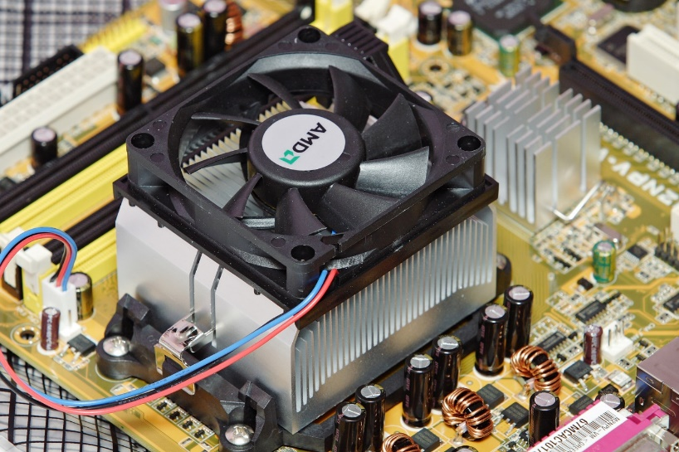

Fig 2.9 A fan-cooled heat sink

**2.7.1 KEY CONSIDERATIONS IN HEAT SINK DESIGN**

1. **Thermal Resistance** - Thermal resistance refers to the sum of resistances to heat flow between the die and the coolant fluid. These heat flow resistances include the resistance between the die and the component casing, the resistance between the casing and the heat sink (thermal interface resistance), and the resistance between the heat sink and the fluid in motion. Thermal resistance does not factor non-uniform heat distribution and it is unsuitable for modeling systems that are not in thermal equilibrium.

Although the thermal resistance value is an approximation, it enables the [modeling and analysis of thermal characteristics](https://www.simscale.com/product/thermal-analysis/) of semiconductor devices and heat sinks. Analyses of different heat sink designs are used to determine heat sink geometries and parameters that enable maximum heat dissipation. Complex modeling of thermal characteristics can be achieved by meshing heat sinks using 3D thermal resistances. In the following image, the SimScale cloud-based [simulation software](https://www.simscale.com/)was used to mesh a heat sink model. The [Hex-dominant Parametric](https://www.simscale.com/docs/content/preprocessing/meshing/meshing_general.html) (only CFD) mesh was used to generate the mesh for the 4 volumes (3 solids and 1 fluid). This is used to create refinements and maintain the volumes as different regions to later define interfaces.

2**. Material** - Heat sinks are designed using materials that have high thermal conductivity such as aluminum alloys and copper. Copper offers excellent thermal conductivity, antimicrobial resistance, biofouling resistance, corrosion resistance, and heat absorption. Its properties make it an excellent material for heat sinks but it is more expensive and denser than aluminum.

Diamond offers a high thermal conductivity that makes it a suitable material for thermal applications. Its lattice vibrations account for its outstanding thermal conductivity. Composite materials such as [AlSiC](https://en.wikipedia.org/wiki/AlSiC), [Dymalloy](https://en.wikipedia.org/wiki/Dymalloy), and copper-tungsten pseudo-alloy are also commonly used in thermal applications.

3. **Arrangement, Shape, Size, and Location of Fins** - The flow of the coolant medium is greatly impacted by the arrangement of fins on a heat sink. Optimizing the configuration helps to reduce fluid flow resistance thus allowing more air to go through a heat sink. The heat sink’s performance is also determined by the shape and design of its fins. Optimizing the shape and size of the fins helps to maximize the heat transfer density. Through modeling, the performance of different fin shapes and configurations can be evaluated.

4. **Fin Efficiency** - A heat sink fin receives heat from an electronic device and dissipates it into the surrounding coolant fluid. The heat transferred by a fin to the coolant medium decreases as the distance from the base of the heat sink increases. Using a material that has a higher thermal conductivity and decreasing the aspect ratio of the fins help to boost the fins’ overall efficiency. In the following image, the SimScale platform was used to analyze the temperature characteristics of a heat sink design.

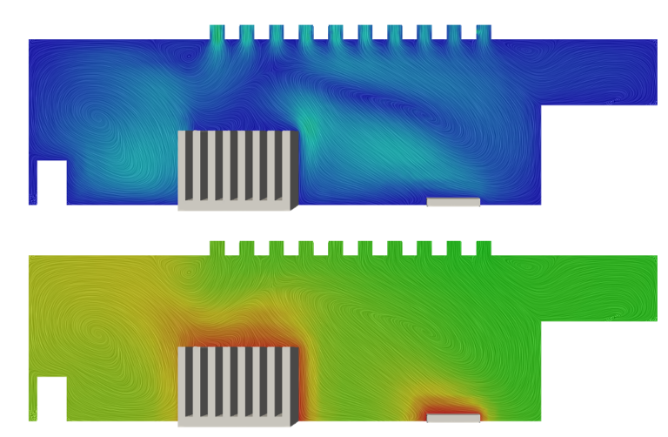

Fig 2.10 Temperature Streamlines

 5. **Thermal Interface Material** - Surface defects, roughness, and gaps increase thermal contact resistance thereby reducing the effectiveness of a thermal solution. These defects increase the heat flow resistance by reducing the thermal contact area between an electronic component and its heat sink. Thermal resistance is reduced by increasing the interface pressure and decreasing the surface roughness. In most cases, there are limits to these resistance reduction methods.

To overcome these limits, thermal interface materials are used. The electrical resistivity of a material, contact pressure, and size of the surface gaps should be considered when selecting a thermal interface material for a given thermal application.

6. **Heat Sink Attachment Methods -** The thermal performance of a heat sink can be enhanced by selecting an appropriate method of attaching a heat sink to an electronic device or component. The selection process should factor in both the thermal and the mechanical requirements of the thermal management solution. Common heat sink attachment methods include standoff spacers, flat spring clips, epoxy, and thermal tape.